Audit S2D script

Tech-Coffee | SeromIT

Documentation about Audit-S2D.ps1

Romain Serre

2017

About Author

Romain Serre [Twitter](https://twitter.com/@romserre) [LinkedIn](https://fr.linkedin.com/in/romainserre) [Blog](http://www.tech-coffee.net/)

[MVP Profile](https://mvp.microsoft.com/fr-fr/PublicProfile/5001608?fullName=Romain%20%20Serre)

[VMware vExpert Profile](https://communities.vmware.com/docs/DOC-36000)

Romain Serre works in Lyon as a Technical Architect. He is focused on storage, virtualization, network, backup and Cloud technologies.

He works especially on hyperconverged solution such as Microsoft Storage Spaces Direct / Hyper-V, VMware vSAN and Nutanix. In part of his job, Romain implements also backup solution based on Veeam backup & Replication. Moreover, he works on System Center, Windows Server technologies (Active Directory, PKI and so on) and Microsoft Azure.

Romain has been recognized MVP and VMware vExpert 2017.

He is certified Microsoft Certified Solution Expert (Server Infrastructure & Private Cloud), on Hyper-V and on Microsoft Azure (Implementing a Microsoft Azure Solution).

Romain blogs in all of these technologies at <http://www.tech-coffee.net>

Special thanks

I could not have release this script without test it on several S2D infrastructure. So I’d like to thanks my fellow Dave Kawula, Charbel Nemnom and Kristopher Turner. They helped me to resolve most of the issue of this script. Thank you for your time guys!

About the script

# Revision

* **0.1**: Initial version
* **0.2**: Add option to export path
* **0.3**: Change consolidation rate to not take into account hyperthreading
* **0.4**: Resolve bugs, add information
* **0.5**: Force charset to UTF-8, resolve special char issue. Add trademark.
* **0.6**: Resolve an issue to match the Network Adapter with VMNetworkAdapter

# Roadmap

* Manage disaggregated environment (SOFS + file shares)
* Show information about Cache / Capacity Ratio
* Show information about reserved space for automatic rebuilding processor

# Not supported environment

* Windows Server 2012 R2 or older version are not supported
* Disaggregated S2D deployment model not suppoted (yet)
* (Not Tested) Nodes running on other language than EN-US. Maybe it’s work, but I don’t know

# Description

In a part of my job, I deploy a lot of Storage Spaces Direct cluster, especially in hyperconverged deployment model. When I implement this kind of infrastructure, I have to ensure that all nodes are consistent in term of settings. To avoid to run hundred of PowerShell cmdlet and to make manual comparison, I decided to write a script to make the job for me.

Audit-S2D lists all nodes of a S2D cluster, and gathers information about compute, network, storage, cluster and VM. Then, the script generates an HTML file with the collected information. The generated board is easy to use and you can quickly verify each important setting for an S2D cluster.

Usually I use the script to show to customer that his solution is ready. But you can run the script in a daily basis to get information about the configuration.

# Dashboard example

In the below screenshot, you can see a dashboard generated from my S2D cluster in lab (restroom ? :p)

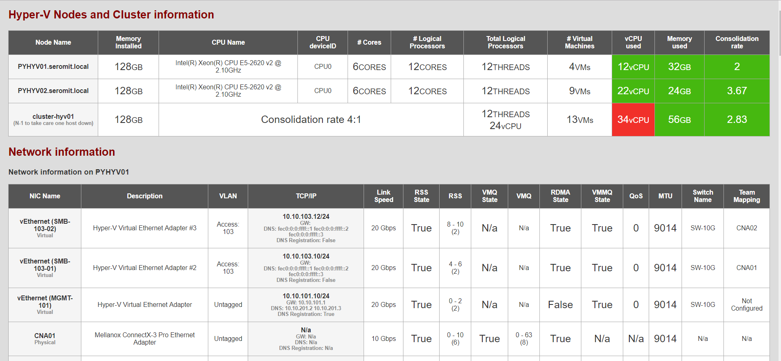

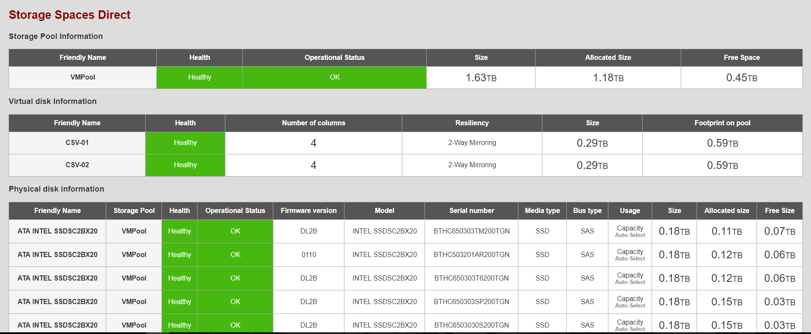

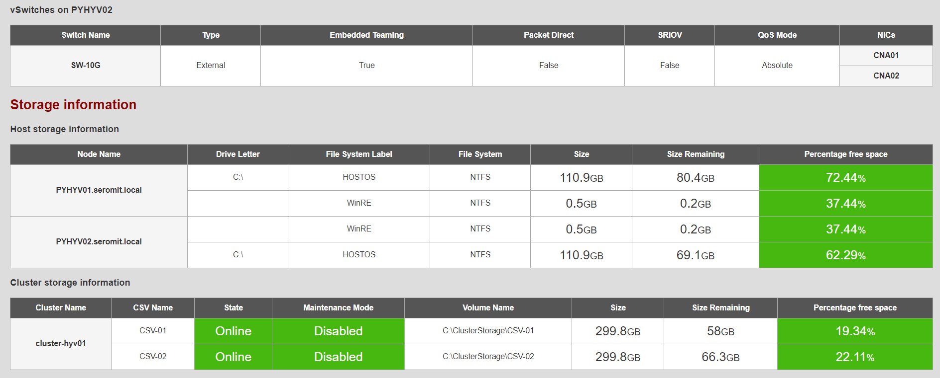

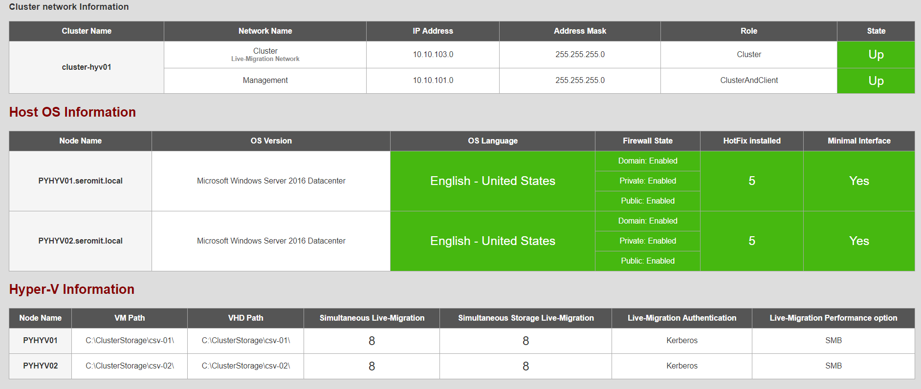

# How I download the script?

You can get the script from my Github:

<https://github.com/SerreRom/TechCoffee/tree/master/PowerShell/Audit-S2D>

# Change settings

All settings that you can change are located in the section **##### Settings #####**

## Consolidation rate

In the script, there is some settings you can change. First of all, this is the consolidation rate. Usually, I plan infrastructure with a consolidation rate of 4. You can change this value for your environment. To change it, modify the variable called **$TxConso**

## Disable dashboard section

Maybe you are not interested by some section in the dashboard. The script allows to disable dashboard section. For example, you can disable Virtual Machine information section. In the settings section, there is several variables you can change to disable unwanted section:

###### 0 = Disabled; 1 = Enabled

# Enable Host hardware collecting information

$HostHwInformation = 1

# Enable Host network collecting information

$HostNetInformation = 1

# Enable Host storage collecting information

$HostStoInformation = 1

# Enable cluster storage collecting information

$ClustStoInformation = 1

# Enable Cluster Network collecting information

$ClustNetInformation = 1

# Enable Host OS collecting information

$HostOSInformation = 1

# Enable Cluster configuration collecting information

$ClustConfInfo = 1

# Enable Virtual Machine collecting information

$VMHostWorkloadInfo = 1

# Enable Storage Spaces Direct Collecting information

$ClusterS2D = 1

# How to run it

Once you have downloaded the script, you can run it from a node of the cluster or remotely. Below you can find an example to run the script:

**.\Audit-S2D.ps1 -DomainName "Mydomain.local" `**

**-ClusterName "MyclusterName" `**

**-Path "C:\Where\the\dashboard\is\generated" `**

**-Credential "mydomain\myaccount"**

Once the script is finished, a HTML file is generated in the **path** folder and the name contains the cluster name and the current date.